20 Security — Restrict Unused Ports
WHY ARE WE DOING THIS?
Because:
- Unused switch ports are a security risk.
- Attackers can plug into these ports and access your VLAN.
- By shutting down unused ports, we prevent unauthorized access.
- This is a basic Layer 2 security best practice.

ADVANTAGES
- Prevent unauthorized access
  - Unused ports cannot be used by rogue devices.
- Reduce attacks like MAC flooding
  - Attackers can’t misuse open ports.
- Simpler network management
  - Only active ports are allowed to transmit traffic.
- Better network hygiene
  - Keeps VLANs clean and controlled.

DISADVANTAGES / LIMITATIONS
- Must manually enable ports when needed.
- If not documented, legitimate users may be blocked.
enable
configure terminal

! -------------------------
! Hostname and SSH
! -------------------------
hostname INBOM25CS1
ip domain-name adityalab.com
username admin privilege 15 secret qwertyuiop
ip ssh version 2
crypto key generate rsa general-keys modulus 1024

! -------------------------
! Enable routing (for inter-VLAN, optional)
! -------------------------
ip routing

! -------------------------
! VLANs
! -------------------------
vlan 10
name Sales
exit

vlan 20
name HR
exit

vlan 30
name IT
exit

vlan 39
name Management
exit

! -------------------------
! SVI Interfaces (Gateway for each VLAN)
! -------------------------
interface vlan 10
ip address 192.168.10.1 255.255.255.0
no shutdown
exit

interface vlan 20
ip address 192.168.20.1 255.255.255.0
no shutdown
exit

interface vlan 30
ip address 192.168.30.1 255.255.255.0
no shutdown
exit

interface vlan 39
ip address 192.168.1.10 255.255.255.0
no shutdown
exit

! -------------------------
! Access Ports
! -------------------------
interface range gi1/0/1 - 6
switchport mode access
switchport access vlan 10
no shutdown
exit

interface range gi1/0/7 - 12
switchport mode access
switchport access vlan 20
no shutdown
exit

interface range gi1/0/13 - 18
switchport mode access
switchport access vlan 30
no shutdown
exit

interface gi1/0/24
switchport mode access
switchport access vlan 39
no shutdown
exit

! -------------------------
! Trunk Port to Switch 2
! -------------------------
interface gi1/1/4
switchport mode trunk
switchport trunk allowed vlan all
no shutdown
exit

! -------------------------
! DHCP Pools
! -------------------------
ip dhcp excluded-address 192.168.10.1
ip dhcp excluded-address 192.168.20.1
ip dhcp excluded-address 192.168.30.1

ip dhcp pool SALES
network 192.168.10.0 255.255.255.0
default-router 192.168.10.1
dns-server 8.8.8.8
exit

ip dhcp pool HR
network 192.168.20.0 255.255.255.0
default-router 192.168.20.1
dns-server 8.8.8.8
exit

ip dhcp pool IT
network 192.168.30.0 255.255.255.0
default-router 192.168.30.1
dns-server 8.8.8.8
exit

! -------------------------
! Enable SSH on VTY
! -------------------------
line vty 0 4
login local
transport input ssh
exit

! -------------------------
! Command History
! -------------------------
line console 0
history size 256
exit

line vty 0 4
history size 256
exit

! -------------------------
! VLAN Security — Shutdown unused ports
! -------------------------
interface range gi1/0/19 - 23
shutdown
exit

! -------------------------
! Port Security on active ports (PC-only, max 1 device)
! -------------------------
interface range gi1/0/1 - 18
switchport port-security
switchport port-security maximum 1
switchport port-security violation restrict
switchport port-security mac-address sticky
exit

! Trunk and management ports left untouched

ex
write memory

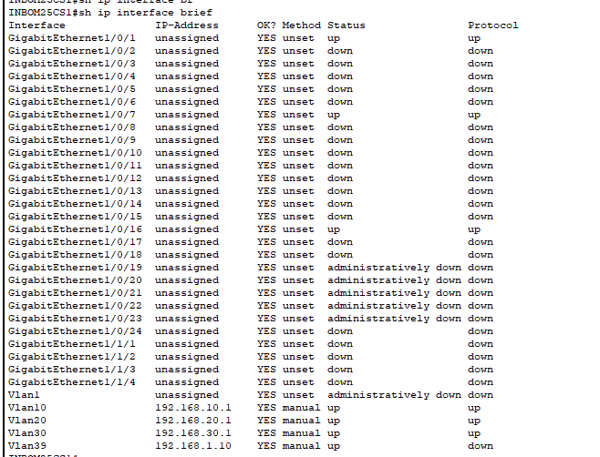
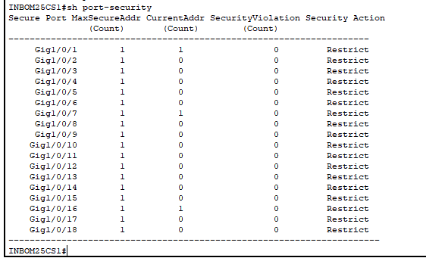
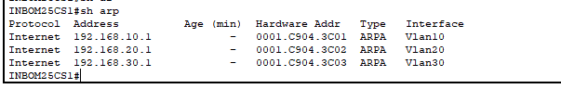
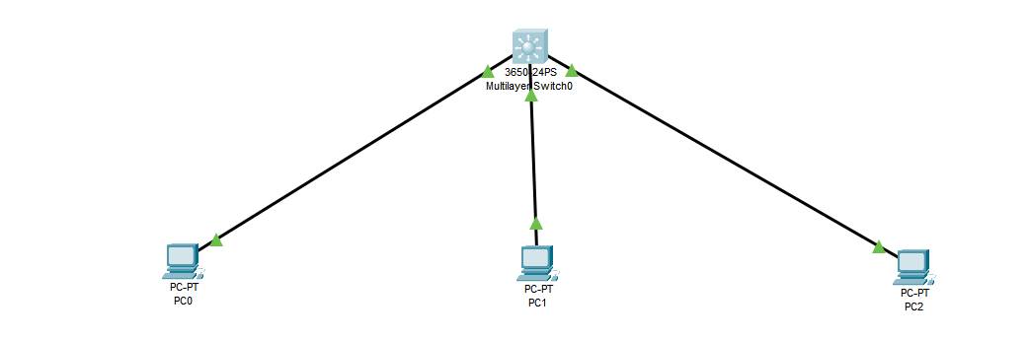
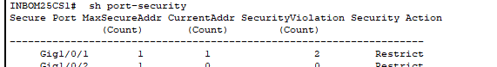
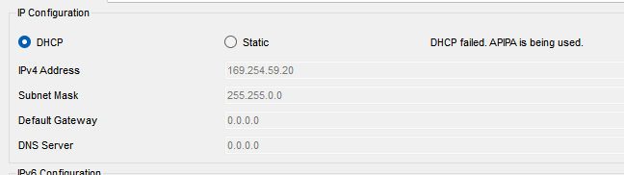
Connecting same device after connecting same device
